BOBCAT-DI:
Survey and Evaluation Report



Army Research Laboratory,
Adelphi MD

from

Laboratory for Language and Media Processing
University of Maryland, College Park, MD, USA

October 7, 2008

Table of Contents

Table of Contents 2
List of Figures 4
_Toc211610827
BOBCAT-DI 5
1 Introduction 5
1.1 Background 5
1.2 Related Work 5
1.3 Organization of Report 5
2 Evaluation Metrics and Protocols 6
2.1 Overview 6
2.2 Related Work 6
2.3 PETS 6
2.4 ImDiff 6
3 Datasets 14
4 Algorithms 15
4.1 Unsupervised Text Line Detection using Affinity Propagation [1] 15
4.1.1 Introduction 15
4.1.2 Affinity Propagation 15
4.1.3 Approach 15
4.1.4 Publications 17
4.2 Document Zone Classification using Partial Least Squares and Hierarchical Classifiers 18
4.2.1 Introduction 18
4.2.2 Approach 18
4.2.3 Evaluation 18
4.2.4 Publications 19
4.3 Rule Line Removal in Binary Document Images using Support Vector Data Description 20
4.3.1 Introduction 20
4.3.2 Approach 20
4.3.3 Preliminary Results 21
4.3.4 Evaluation Dataset 22
5 Sample Evaluations 23
5.1 Overview 23
5.2 Page Segmentation 23
5.3 Page Classification 23
5.4 Noise and Clutter Cleaning 23
5.5 Line Removal 23
5.6 Line Detection 23
6 Summary and Conclusions 24
7 Bibliography 25

List of Figures

Figure 1: Example of a ground truth Text image. 8
Figure 2: Example of a ground truth Text Line Image 9
Figure 3: Image created by addition of the text image and text line template from Figure 1 and Figure 2 respectively. 10
Figure 4: A sample output of Line Removal Output. 11
Figure 5: Missed Detections in the output image 12
Figure 6: False detections in the output image 13
Figure 7: Sample Image 16
Figure 8: Original Document Image 20
Figure 9: Document Image with Page Rule Lines Removed 20
Figure 10: Original Document Image 20
Figure 11: Document Image with Page Rule Lines Removed 21

BOBCAT-DI

Introduction

Background

Over the past five decades, evaluation has become an increasing

Related Work

Organization of Report

Evaluation Metrics and Protocols

Overview

Related Work

PETS
See PETS Documentation Temporarily

ImDiff

There is a class of document analysis problems which require analysis, and thus evaluation, at the pixel level and we refer to these problems as detection problems. One example of this includes line detection and removal and second example is general noise removal. Pixels of these classes are often interspersed with content so the “detection” must be done at a pixel level.
For this class of problems, we assume that we have a set of pixels we want to detect which we refer to as the template. From this template, we can look at the number of pixels that are missed and falsely detected, as well as a percentage of missed as a function of the number of pixels in the template, and the percentage of false, as a function of the number of pixels in the original or result image.
For example, for line removal the goal is to detect and remove line pixels from the image. Suppose we have document images which contains only text lines, generated by scanning some of the ruled line pages, that we call ground truth line image. Then, we also have documents that contain only text (and no lines), which is called ground truth text image. Using the line templates and text images, we further generate documents that have line overlapping with text, by simply addition of the images to generate our test images. For evaluation we will identify the pixels that are in the textline image that are not in the text image to define our line template.
Our line removal algorithm is run on these test images, where try to remove the line pixels that do not overlap with the text. The output is the document image with only text pixels without the “line pixels” in the template Since we have the original document, we can evaluate the accuracy of our algorithm by finding the total number of missed line pixels and false line pixels in the output image which is defined as follows:

CASE 1: Goal is to remove template pixels.

Missed Detections: Foreground pixels that are present in the template and remain in the output image.

False Detections: Foreground pixels that are present in the test (or original) image, but not in the template, and are not in the output image.

We can express the above measure relative to the total number of pixels as follow:

Missed %= (Number of Missed Pixels / Pixels in template)*100

False % = (Number of False Pixels / Pixels in original image)*100

CASE 2: Goal is to retain only template pixels.

Missed Detections: Foreground pixels that are present in the template and are missing in the output image.

False Detections: Foreground pixels that are not present in template image and are present in the output image.

We can express the above measure relative to the total number of pixels as follow:

Missed %= (Number of Missed Pixels / Pixels in template)*100

False % = (Number of False Pixels / Pixels in output image)*100

Above evaluation can be understood by following figures which is taken from our dataset for Case I.

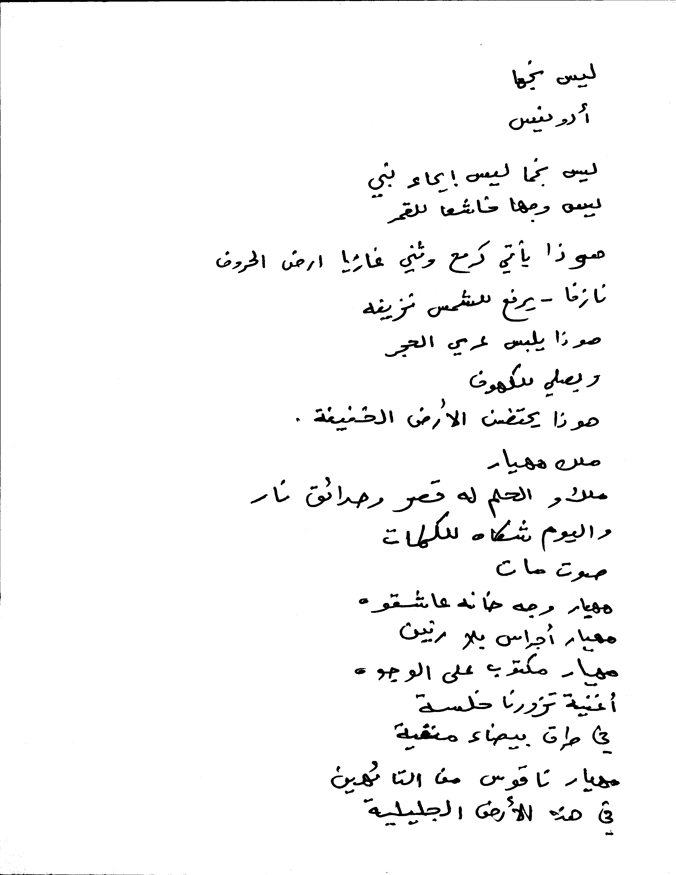

Figure 1: Example of a ground truth Text image.



Figure 2: Example of a ground truth Text Line Image

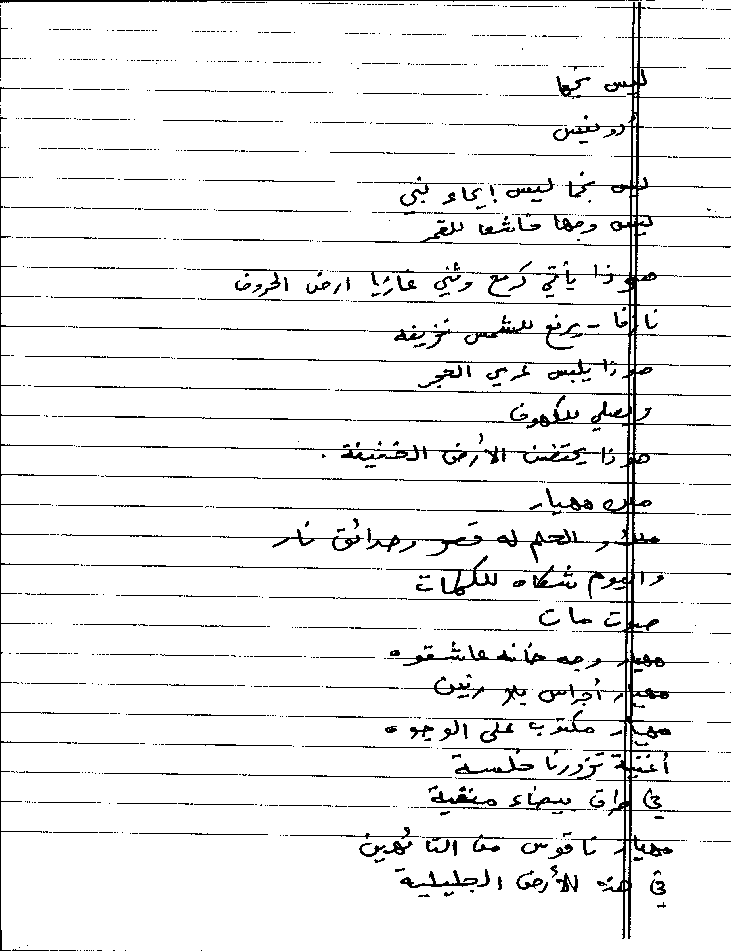

Figure 3: Image created by addition of the text image and text line template from Figure 1 and Figure 2 respectively.

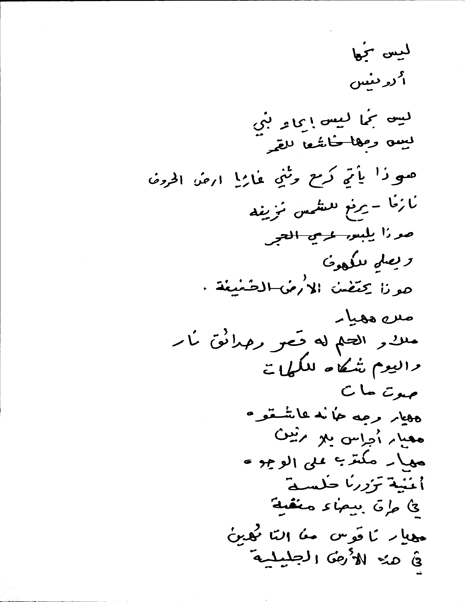

Figure 4: A sample output of Line Removal Output.

We can see some of the parts of Line still remaining over the text and some of the text pixels missing.



Figure 5: Missed Detections in the output image



Figure 6: False detections in the output image

For the above example we have following:

Total number of text pixels: 265911
Total number of Line Only Pixels (which do not overlap with text): 307527
Missed Detections (line pixels that are not removed): 2028
False Detections (text pixels that are removed): 2971
Missed Percentage = 0.9661 %
False Percentage = 0.7627 %

Datasets
See Evaluations Spread Sheets Temporarily

Algorithms

Unsupervised Text Line Detection using Affinity Propagation [1]

Introduction
Automatic detection of text lines in Arabic handwritten documents is a fundamental step prior to any further Optical Character Recognition (OCR) or automatic translation. The purpose of this task is to develop a robust, unsupervised text line detection algorithm for Arabic handwritten documents. Such an algorithm must have two main characteristics – (1) the designed algorithm must accurately detect text lines in different orientations and (2) the designed algorithm must detect text lines in near real-time.

Affinity Propagation
Affinity Propagation (AP) [2] is a recently developed unsupervised data clustering technique. AP depends on passing messages between data points. Two types of messages are passed between data points – (1) availability messages indicate the availability of a given data point to serve as a cluster center for the neighboring data points and (2) responsibility messages indicate the willingness of a certain data point to be a member of a specific cluster. These two types of messages are passed based on the similarity between pairs of data points.

AP has two main advantages. First, the number of cluster need not be a priori specified. Second, AP is very flexible because it is independent on the method used to compute the pair-wise similarities.

Approach
We adopt an unsupervised, hierarchical clustering methodology to automatically detect text lines in multiple orientations in Arabic handwritten documents. Text lines are detected in two steps. First, the orientations of the document’s connected components are used to compute a pair-wise similarity matrix using exponential kernels. AP is applied to the orientation similarity matrix to cluster the document into a number of text areas with homogenous orientations.

For each of the detected text areas, a pair-wise similarity matrix is computed using exponential kernels using the projections perpendicular to the orientation. AP is applied using the similarity matrix and text lines are detected.

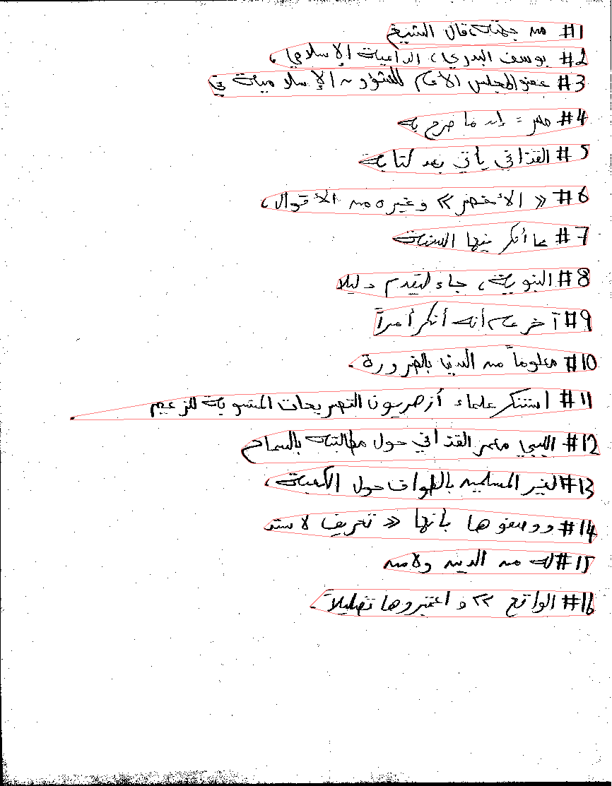

Figure 7: Sample Image

Publications
[1] Wael Abd-Almageed and David Doermann, “Text Line Detection in Arabic Handwritten Documents,” To be submitted to International Conference on Document Analysis and Recognition, Barcelona, Spain, July 2009.
[2] B. Frey and D. Dueck,” Clustering by Passing Messages Between Data Points,” Science, pp. 972—976, 2007.

Document Zone Classification using Partial Least Squares and Hierarchical Classifiers

Introduction
Identifying the content type of document zones is a fundamental component of modern document analysis systems. For example, identifying zone type allows the application of content-specific algorithms and can improve Optical Character Recognition (OCR) by providing domain knowledge. More importantly, zone type identification is crucial to indexing and retrieval of large document databases.

Broadly speaking, content analysis algorithms can be classified as one of three main approaches -- (1) type-specific detection, (2) page classification and (3) zone classification. Type-specific approaches, emphasize finding specific types of zones, such as text regions, logos, mathematical expressions and tables. Page classification approaches, assume the content of the entire page is of a single type (e.g. title page or index page) and a classifier is used to determine the page content. Finally, zone classification approaches assume that the page is segmented into zones with independent content types. Low level image features are extracted from each zone and a statistical classifier is used to label the different zones into one of possible content types (e.g. text, math, etc.).

Approach
Classically, multi-class classification problems have been treated by either constructing a number of one-against-all binary classifiers or constructing a number of one-against-one binary classifiers, with the latter method reported to be the most successful one. A voting scheme is then used to determine the required class label. One-against-one method suffers a principal limitation. If the observation being tested does not belong to either of the two classes on which the classifier is trained, a vote will be incorrectly cast, biasing the final classification outcome. To overcome this limitation, we used a novel approach by constructing hybrid of the two approaches.
We construct a number of two-against-all classifiers, which will be used to determine if a vote will be cast to a given class. Based on the decision of the two-against-all classifier, a regular one-against-one classifier is used to label the test sample and cast the vote. This mechanism prevents casting incorrect votes if the test sample does not belong to either of the two classes modeled by the one-against-one classifier.

Evaluation
We applied our new approach to the University of Washington (UW) data set. The dataset contains 1690 document images with a total of 24531 zones. We considered 10 different zone types -- -- chemical drawing, small text and symbols, drawing, halftone, logo or seal, map, math, ruling, table and large text. Using SVM as the underlying binary classifier, hybrid classifier achieves 97.3% classification accuracy. To our knowledge, the best reported performance on this dataset is 98.45% of Wang et al. [2]. However, the UW data set is significantly unbalanced with 87.9% small text samples and 0.065% logo and seal samples and 0.057% map samples, which skews the classifier performance. The approach of Wang et al. [2] has not been tested on a balanced data set.
In order to further assess our proposed algorithm, we eliminated small text, logo and seal and map classes from the dataset which leaves a balanced data set of seven zone classes. The hybrid classifier achieves a comparable 96.6% accuracy. No result is available for a similar experiment from [2]. Moreover, similar experiments show that the hybrid classification scheme out-performs the classic one-against-one scheme. The following table summarizes the results.

 | 1-vs-1 | Wang et al. [2] | Hybrid
Unbalanced | 93.1% | 98.45 | 97.3%
Balanced | 88.2% | N/A | 96.6%

Publications
[1] Wael Abd-Almageed, Mudit Agrawal, Wontaek Seo and David Doermann, “Document Zone Classification using Partial Least Squares and Hybrid Classifiers,” Accepted, International Conference on Pattern Recognition, Tampa, Florida, December, 2008.
[2] W. Wang, I. T. Phillips and R. M. Haralick, “Document Zone Content Classification and Its Evaluation”, Pattern Recognition, 39(1), 2006.

Rule Line Removal in Binary Document Images using Support Vector Data Description

Introduction
The purpose of this task is to develop an algorithm for automatically removing the background rule lines in order to improve the overall quality of the document image prior to further processing steps, such as Optical Character Recognition (OCR). Two objectives are taken into consideration when designing our rule line removal algorithm. First, the algorithm must not depend on explicitly detecting rule lines prior to removing them. Methods that depend on detecting the rule lines (e.g. using Hough Transform) are prone to making estimation errors and usually have many parameters that are difficult to tune for a large distribution of document pages. Therefore, we need to design an algorithm that performs well on documents with and without rule lines. Second, the algorithm designed must not degrade the quality of the textual connected components when applied to non-rule lines pixels.

Approach
Page rule lines represent a distinct data domain versus other document content types, such as text, logos and signatures. The classic approach in such cases is using a multi-class classifier. However, multi-class classifiers are not suitable for this problem because (1) the required large training sets from different classes and (2) the limitations in currently used voting schemes, as we have pointed out in [1] and (3) the objective is to identify pixels that belong to the rule line class versus other pixel types, rather than actually identifying other pixel types.

Consequently, we will use data domain description methods for characterizing page rule lines. The objective is to completely describe the data domain while rejecting outlier data. For this purpose, we used Support Vector Data Description (SVDD) to describe the observations extracted from rule lines. SVDD is inspired by Support Vector Machines (SVM) and it describes the data domain using a hypersphere in a higher dimensional feature space. The hypersphere is characterized by the support vectors of the data domain.

Binary document images restrict feature extraction choices. Therefore, in order to obtain a pseudo-gray scale representation of the document image, we compute the directional gradient of the Distance Transform (DT) of the binary image. The magnitude of the gradient is discarded and the direction of the gradient is use a pseudo gray scale representation.

The texture of the pseudo gray image will be used to distinguish between pixels that belong to page rules lines versus text pixels. Texture features are extracted using a Gabor Filter Bank.

Preliminary Results
Figures 1 and 3 show examples of document images with page rule lines. Applying classic line detection methods on this image fails because of the discontinuities in the rule lines. Figures 2 and 4 show the results of applying our SVDD-based classifier to remove rule lines. The figure demonstrates that the developed classifier correctly remove pixels that belong to the rule lines if they not indeed part of a larger connected component representing true content.


Figure 8: Original Document Image

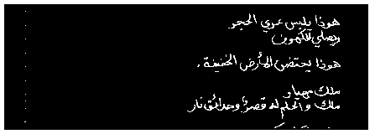
Figure 9: Document Image with Page Rule Lines Removed


Figure 10: Original Document Image

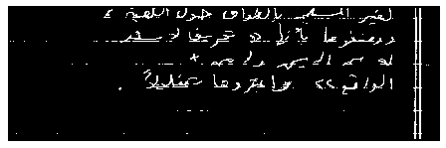
Figure 11: Document Image with Page Rule Lines Removed

Evaluation Dataset
In order to evaluate our rule line removal algorithm, we built a dataset of 100 document images. The 100 images are evenly collected from TOBACO, Anfal, Harmony and AMA datasets. The 100 images are chosen such that 50 images contain document lines and 50 images contain only textual content.

Since a pixel-level annotation for page lines is virtually impossible, we are currently in the process of developing an evaluation methodology that does not require pixel-level annotation. The developed algorithm will be applied to the image set and evaluation results will be reported as soon as they are available.

Sample Evaluations

Overview

See Evaluations Spread sheets Temporarily.

Page Segmentation

Page Classification

Noise and Clutter Cleaning

Line Removal

Line Detection

Summary and Conclusions

Bibliography

Surveys

article(bb86769)
Andersson, P.
Optical Character Recognition: A Survey
Datamation, 1969, Vol. 15(7), pp. 43-48
article(bb86794)
Chen, N. & Blostein, D.
A survey of document image classification: problem statement, classifier architecture and performance evaluation
#IJDAR#, 2007, Vol. 10(1), pp. 1-16
article(bb86774)
Elliman, D. & Lancaster, I.
A Review of Segmentation and Contextual Analysis Techniques for Text Recognition
#PR#, 1990, Vol. 23(3-4), pp. 337-346
article(bb86925)
Embley, D., Hurst, M., Lopresti, D. & Nagy, G.
Table-processing paradigms: a research survey
#IJDAR#, 2006, Vol. 8(2-3), pp. 66-86
article(bb86773)
Govindan, V. & Shivaprasad, A.
Character Recognition: A Review
#PR#, 1990, Vol. 23(7), pp. 671-683
article(bb86775)
Impedovo, S., Ottaviano, L. & Occhinegro, S.
Optical Character Recognition: A Survey
#PRAI#, 1991, Vol. 5, pp. 1-24
article(bb86792)
Liang, J., Doermann, D. & Li, H.
Camera-based analysis of text and documents: a survey
#IJDAR#, 2005, Vol. 7(2-3), pp. 84-104
inproceedings(bb86750)
Loke, R. & du Buf, J.
Small CPU times and fast interactivity in sonar seabottom surveys
3DPVT04
2004, pp. 844-851
article(bb86772)
Mori, S., Suen, C. & Yamamoto, K.
Historical Review of OCR Research and Development
#PIEEE#, 1992, Vol. 80(7), pp. 1029-1058
article(bb86782)
Tang, Y., Lee, S. & Suen, C.
Automatic Document Processing: A Survey
#PR#, 1996, Vol. 29(12), pp. 1931-1952

Page Segmentation
article(bb87299)
Amin, A. & Shiu, R.
Page Segmentation And Classification Utilizing Bottom-up Approach
#IJIG#, 2001, Vol. 1(2), pp. 345-361
article(bb87289)
Antonacopoulos, A.
Page Segmentation Using the Description of the Background
#CVIU#, 1998, Vol. 70(3), pp. 350-369
inproceedings(bb87243)
Antonacopoulos, A. & Ritchings, R.
Flexible page segmentation using the background
#ICPR94#
1994, pp. B:339-344
inproceedings(bb87278)
Cantoni, V., Cinque, L., Lombardi, L. & Manzini, G.
Page Segmentation Using a Pyramidal Architecture
#CAMP97#
1997, pp. Session 6
article(bb87273)
Chen, J.
A Simplified Approach to the HMM Based Texture Analysis and Its Application to Document Segmentation
#PRL#, 1997, Vol. 18(10), pp. 993-1007
article(bb87279)
Cinque, L., Levialdi, S., Lombardi, L. & Tanimoto, S.
Segmentation of page images having artifacts of photocopying and scanning
#PR#, 2002, Vol. 35(5), pp. 1167-1177
inproceedings(bb87282)
Cinque, L., Levialdi, S. & Malizia, A.
A system for the automatic layout segmentation and classification of digital documents
#CIAP03#
2003, pp. 201-206
inproceedings(bb87281)
Cinque, L., Levialdi, S., Malizia, A. & de Rosa, F.
DAN: An Automatic Segmentation and Classification Engine for Paper Documents
#DAS02#
2002, pp. 491 ff.
article(bb87277)
Cinque, L., Lombardi, L. & Manzini, G.
A Multiresolution Approach for Page Segmentation
#PRL#, 1998, Vol. 19(2), pp. 217-225
article(bb86920)
Das, A., Saha, S. & Chanda, B.
An empirical measure of the performance of a document image segmentation algorithm
#IJDAR#, 2002, Vol. 4(3), pp. 183-190
article(bb87268)
Etemad, K., Doermann, D. & Chellappa, R.
Multiscale Segmentation of Unstructured Document Pages Using Soft Decision Integration
#PAMI#, 1997, Vol. 19(1), pp. 92-96
inproceedings(bb87269)
Etemad, K., Doermann, D. & Chellappa, R.
Multiscale Document Page Segmentation Using Soft Decision Integration
#UMD#
1995
inproceedings(bb87270)
Etemad, K., Doermann, D. & Chellappa, R.
Page Segmentation Using Decision Integration and Wavelet Packets
#ICPR94#
1994, pp. B:345-349
article(bb86776)
Fujisawa, H., Nakano, Y. & Kurino, K.
Segmentation Methods for Character Recognition: From Segmentation to Document Structure Analysis
#PIEEE#, 1992, Vol. 80(7), pp. 1079-1092
article(bb87260)
Jain, A. & Bhattacharjee, S.
Text Segmentation Using Gabor Filters for Automatic Document Processing
#MVA#, 1992, Vol. 5, pp. 169-184
inproceedings(bb87291)
Jain, A. & Yu, B.
Model-Based Document Representation: Application to Page Segmentation
#ICDAR97#
1997, pp. Mo-2B
article(bb87258)
Jain, A. & Zhong, Y.
Page Segmentation Using Texture Analysis
#PR#, 1996, Vol. 29(5), pp. 743-770
inproceedings(bb87259)
Jain, A. & Zhong, Y.
Page segmentation using texture discrimination masks
#ICIP95#
1995, pp. III: 308-311
article(bb87274)
Kise, K., Sato, A. & Iwata, M.
Segmentation of Page Images Using the Area Voronoi Diagram
#CVIU#, 1998, Vol. 70(3), pp. 370-382
article(bb87283)
Liu, J. & Tang, Y.
Distributed Autonomous Agents For Chinese Document Image Segmentation
#PRAI#, 1998, Vol. 12(1), pp. 97-118
inproceedings(bb87237)
Liu, J., Tang, Y., He, Q. & Suen, C.
Adaptive document segmentation and geometric relation labeling: algorithms and experimental results
#ICPR96#
1996, pp. III: 763-767
inproceedings(bb87297)
Mao, S. & Kanungo, T.
Automatic Training of Page Segmentation Algorithms: An Optimization Approach
#ICPR00#
2000, pp. Vol IV: 531-534
inproceedings(bb87211)
de Mello, C.
Image Segmentation of Historical Documents: Using a Quality Index
#ICIAR04#
2004, pp. II: 209-216
article(bb87253)
Nadler, M.
Document Segmentation and Coding Techniques
#CVGIP#, 1984, Vol. 28(2), pp. 240-262
article(bb87265)
Patel, D.
Page Segmentation for Document Image-Analysis Using a Neural-Network
#OptEng#, 1996, Vol. 35(7), pp. 1854-1861
inproceedings(bb87255)
Pavlidis, T.
Page Segmentation by White Streams
#ICDAR91#
1991, pp. 945-953
article(bb87254)
Pavlidis, T. & Zhou, J.
Page Segmentation and Classification
#GMIP#, 1992, Vol. 54(6), pp. 484-496
inproceedings(bb87267)
Payne, J., Stonham, T. & Patel, D.
Document segmentation using texture analysis
#ICPR94#
1994, pp. B:380-382
article(bb87286)
de Queiroz, R. & Eschbach, R.
Fast Segmentation of the JPEG Compressed Documents
#JEI#, 1998, Vol. 7(2), pp. 367-377
inproceedings(bb87287)
de Queiroz, R. & Eschbach, R.
Segmentation of Compressed Documents
#ICIP97#
1997, pp. III: 70-73
article(bb87263)
Shih, F. & Chen, S.
Adaptive Document Block Segmentation and Classification
#SMC-B#, 1996, Vol. 26(5), pp. 797-802
inproceedings(bb87214)
Sylwester, D. & Seth, S.
Adaptive segmentation of document images
#ICDAR01#
2001, pp. 827-831
article(bb87262)
Venkateswarlu, N. & Boyle, R.
New segmentation techniques for document image analysis
#IVC#, 1995, Vol. 13(7), pp. 573-583
article(bb87292)
Yang, J. & Tsai, W.
Document image segmentation and quality improvement by moiré pattern analysis
#SP:IC#, 2000, Vol. 15(9), pp. 781-797
article(bb87256)
Zlatopolsky, A.
Automated Document Segmentation
#PRL#, 1994, Vol. 15(7), pp. 699-704

Layout Analysis
inproceedings(bb86931)
Antonacopoulos, A. & Bridson, D.
Performance Analysis Framework for Layout Analysis Methods
#ICDAR07#
2007, pp. 1258-1262
inproceedings(bb87235)
Baird, H. & Ittner, D.
Language-Free Layout Analysis
#ICDAR93#
1993, pp. 336-340
inproceedings(bb86989)
Bulacu, M., van Koert, R., Schomaker, L. & van der Zant, T.
Layout Analysis of Handwritten Historical Documents for Searching the Archive of the Cabinet of the Dutch Queen
#ICDAR07#
2007, pp. 357-361
inproceedings(bb87244)
Bussi, S. & Mangili, F.
A semi-automatic method for form layout description
#CIAP95#
1995, pp. 539-544
inproceedings(bb86992)
Chen, S., Mao, S. & Thoma, G.
Simultaneous Layout Style and Logical Entity Recognition in a Heterogeneous Collection of Documents
#ICDAR07#
2007, pp. 118-122
inproceedings(bb87240)
Esposito, F., Malbera, D. & Semeraro, G.
A Knowledge-Based Approach to the Layout Analysis
#ICDAR95#
1995, pp. 466-471
inproceedings(bb87242)
Esposito, F., Malbera, D., Semeraro, G., Annese, E. & Scafuro, G.
An Experimental Page Layout Recognition System for Office Document Automatic Classification: An Integrated Approach for Inductive Generalization
#ICPR90#
1990, pp. I: 557-562
inproceedings(bb86975)
Ishitani, Y.
Document Layout Analysis Based on Emergent Computation
#ICDAR97#
1997, pp. Mo-2B
article(bb87298)
Kanungo, T. & Mao, S.
Stochastic language models for style-directed layout analysis of document images
#IP#, 2003, Vol. 12(5), pp. 583-596
inproceedings(bb87228)
Leung, M. & Twan, T.
Linear Layout Processing
#ICPR98#
1998, pp. Vol I: 403-405
inproceedings(bb86793)
Liang, J.
Processing Camera-Captured Document Images: Geometric Rectification, Mosaicing, and Layout Structure Recognition
#Ph.D.#
2006
inproceedings(bb87200)
Liang, J. & Doermann, D.
Logical Labeling of Document Images Using Layout Graph Matching with Adaptive Learning
#DAS02#
2002, pp. 224 ff.
inproceedings(bb86996)
Liu, D., Chen, D. & Chen, T.
Unsupervised Image Layout Extraction
#ICIP06#
2006, pp. 1113-1116
inproceedings(bb86997)
Liu, D., Chen, D. & Chen, T.
Latent Layout Analysis for Discovering Objects in Images
#ICPR06#
2006, pp. II: 468-471
inproceedings(bb87223)
Watanabe, T. & Sobue, T.
Layout Analysis of Complex Documents
#ICPR00#
2000, pp. Vol IV: 447-450

Ground Truthing
inproceedings(bb86933)
Heroux, P., Barbu, E., Adam, S. & Trupin, E.
Automatic Ground-truth Generation for Document Image Analysis and Understanding
#ICDAR07#
2007, pp. 476-480
article(bb87275)
Hobby, J.
Matching Document Images with Ground Truth
#IJDAR#, 1998, Vol. 1(1), pp. xx-yy
inproceedings(bb87276)
Hobby, J.
Matching Document Images with Ground Truth
#ICDAR97#
1997, pp. Tu-2B
inproceedings(bb86766)
Nartker, T., Bradford, R. & Cerny, B.
A Preliminary Report on UNLV/GT1: A Database for Ground-truth Testing in Document Analysis and Character Recognition
#SDAIR92#
1992, pp. 300-315
inproceedings(bb86797)
Yacoub, S., Saxena, V. & Sami, S.
PerfectDoc: a ground truthing environment for complex documents
#ICDAR05#
2005, pp. I: 452-456
article(bb86787)
Yanikoglu, B. & Vincent, L.
Pink Panther: A Complete Environment for Ground Truthing and Benchmarking Document Page Segmentation
#PR#, 1998, Vol. 31(9), pp. 1191-1204
inproceedings(bb86788)
Yanikoglu, B. & Vincent, L.
Ground-Truthing and Benchmarking Document Page Segmentation
#ICDAR95#
1995, pp. 601-604

Datasets
article(bb86922)
Todoran, L., Worring, M. & Smeulders, A.
The UvA color document dataset
#IJDAR#, 2005, Vol. 7(4), pp. 228-240

Evaluation

inproceedings(bb86941)
Antonacopoulos, A., Karatzas, D. & Bridson, D.
Ground Truth for Layout Analysis Performance Evaluation
#DAS06#
2006, pp. 302-311
inproceedings(bb86942)
Antonacopoulos, A. & Meng, H.
A Ground-Truthing Tool for Layout Analysis Performance Evaluation
#DAS02#
2002, pp. 236 ff.
inproceedings(bb86964)
Du, L., Downton, A., Lucas, S. & Al Badr, B.
Generalized Contextual Recognition of Hand-Printed Documents Using Semantic Trees With Lazy Evaluation
#ICDAR97#
1997, pp. Mo-4B
inproceedings(bb86935)
Ferrer, M. & Valveny, E.
Combination of OCR Engines for Page Segmentation Based on Performance Evaluation
#ICDAR07#
2007, pp. 784-788
article(bb86783)
Hull, J.
Performance Evaluation for Document Analysis
#IJIST#, 1996, Vol. 7(4), pp. 357-362
article(bb86784)
Kanai, J.
Automated Performance Evaluation of Document Image-Analysis Systems: Issues and Practice
#IJIST#, 1996, Vol. 7(4), pp. 363-369
article(bb86789)
Kanungo, T., Baird, H. & Haralick, R.
Special Issue on Performance Evaluation: Theory, Practice, and Impact
#IJDAR#, 2002, Vol. 4(3), pp. 139-139
inproceedings(bb87295)
Kanungo, T. & Mao, S.
Software Architecture of PSET: A Page Segmentation Evaluation Toolkit
#UMD#
2000
article(bb86918)
Liang, J., Phillips, I. & Haralick, R.
Performance Evaluation of Document Structure Extraction Algorithms
#CVIU#, 2001, Vol. 84(1), pp. 144-159
article(bb87294)
Mao, S. & Kanungo, T.
Software Architecture of PSET: A Page Segmentation Evaluation Toolkit
#IJDAR#, 2002, Vol. 4(3), pp. 205-217
article(bb87293)
Mao, S. & Kanungo, T.
Empirical Performance Evaluation Methodology and Its Application to Page Segmentation Algorithms
#PAMI#, 2001, Vol. 23(3), pp. 242-256
inproceedings(bb87296)
Mao, S. & Kanungo, T.
A Methodology for Empirical Performance Evaluation of Page Segmentation Algorithms
#UMD#
1999
inproceedings(bb87220)
Okun, O. & Pietikainen, M.
Automatic Ground-truth Generation for Skew-tolerance Evaluation of Document Layout Analysis Methods
#ICPR00#
2000, pp. Vol IV: 376-379
inproceedings(bb86943)
Sankur, B., Baris, U. & Abak, A.
The Performance Evaluation of Low Level Image Processing Techniques for Document Image Analysis and Recognition
#ICDAR97#
1997, pp. Poste
inproceedings(bb86923)
Todoran, L., Worring, M. & Smeulders, A.
Data GroundTruth, Complexity, and Evaluation Measures for Color Document Analysis
#DAS02#
2002, pp. 519 ff.

Appendix 1: PETS Description

