Abstract— A Video Codec has been implemented using transform coding for reduction of spatial redundancy and unidirectional prediction to reduce temporal redundancy. Coding decisions [I/P frame, Intra/Inter Macro block] are adaptively made to ensure best tradeoff between quality and compression. Shot segmentation is an important step in video content analysis. The automatic partitioning of video into shots involves the detection of transitions. Detecting transitions by extracting the DC image in the compressed domain is advantageous. In this report we extract the DC images from the compressed MPEG stream using the approach given in [2]. We implement the algorithms for cut and wipe detection given in [3] and [4] respectively. We also propose a new algorithm for wipe detection.
Video Codec Implementation, DC Image Extraction and Shot Segmentation
Aravind Sundaresan, Vikas Chandrakant Raykar

Index Terms— DC Image Extraction, Motion Estimation, Shot Segmentation, Video Codec, Wipe Detection.

INTRODUCTION
This report contains the details of the implementation of a Video codec and DC image extraction and shot segmentation of a Video Stream as a part of the elective element.

Video Codec
The video encoder implemented as part of the project incorporates the following features. The codec has been designed to encode monochrome video with frame dimensions (16*M, 16*N) where M and N are integers. Each frame is split into macro blocks and therefore the frame dimensions should be multiples of a 16x16 block. The encoder codes the sequence as a series of I/P frames. The I/P decision is made according to suitability of each method for the current frame. For example, when a scene change is detected, the frame is coded as an I-frame. This makes sense from the compression point of view and also provides better quality especially at lower bit rates. The frames are periodically coded as I-frames according to the INTRA refresh rate parameter that can be set by the user. Temporal prediction is closed loop to avoid the accumulation of quantization error. The Video codec has an option of performing full-pel Motion Estimation in a window of dimensions 48 x 48. The Motion Estimation Algorithm used allows flexible step sizes at each iteration (or step) to obtain better optimality. An option of using full search Motion Estimation for non-real-time applications is also available. Macro blocks within a frame are coded as INTRA or INTER according to the SAD (Sum of Absolute Differences) value achieved. There is a resynchronization marker at the frame level. This is useful when the decoder is unable to properly reconstruct the frame due to some reason (for e.g. bit stream corruption), in which case it can resynchronize to the next frame marker. However the decoder implementation does not currently incorporate this feature.

Elective element
Video analysis involves processing video data and extracting the video content to help achieve the goal of content-based search and retrieval. The first step in video analysis is usually video segmentation or shot segmentation, i.e., partitioning video data into manageable units for easy storage and browsing. A shot is an unbroken sequence each with consistent content. Further video analysis can be performed on a shot.
The automatic partitioning of video into shots involves the detection of transitions. A transition is the boundary between two shots. There are two types of transitions abrupt and gradual. An abrupt transition is an instantaneous change from one shot to another. A cut is an abrupt shot change that occurs in a single frame. Fade, dissolve and wipe are three common types of gradual transitions. A fade is a gradual diminishing or heightening of visual intensity. A dissolve is a fade-out and fade-in with some overlap. A wipe is a transition from one scene to another wherein the new scene is revealed by a moving boundary. A wipe can be either horizontal, vertical or diagonal. Apart from these there are a lot of other fancy types of wipes. A collection of different wipe patterns can be seen in [5].
Shot segmentation can be done both in the pixel domain and the compressed domain. Large part of video content is available in the compressed form. Operations on fully decompressed or uncompressed video does not permit rapid processing because of the data size. It is thus advantageous to use the DC image. The DC image can be extracted from the MPEG stream without full decompression. The advantages of using DC images are two fold. First operations are performed directly on the compressed data thus eliminating the need for full frame decompression. Second we are working on a small fraction of the original data while retaining the most of the essential global information.
In Section III we discuss the implementation of the video codec. Section III-A explains the coding strategy used in the video codec. Section III-B discusses the encoding techniques. and Section III-C the video codec structure. In Section IV we discuss the extraction of DC image from MPEG stream following the approach given in [2]. Section V-A and Section V-B discusses the detection of cut and wipe transition as discussed in [3] and [4] respectively. In Section V-C we propose a new method for wipe detection. Section VI discusses the experimental results obtained.

Literature Survey
A comparison of various video shot boundary detection techniques can be found in [1]. The most common ones are based on pixel differences, statistical differences, histogram, and motion vectors. Shot boundary detection can also be done in the compressed domain (i.e. on the MPEG video stream). The first step involves the extraction of DC images from the MPEG compressed stream. [2] examines the direct reconstruction of DC images from the motion compensated P frames and B frames of MPEG compressed video. [3] discusses the various methods for transition detection using the DC images. Two methods for abrupt transition detection i.e. pixel-based and histogram-based method are discussed. [3] also discusses a method for gradual transition (dissolve, fade in, fade out) detection based on temporal sub sampling. Wipe detection is much more involved than detection of abrupt and other gradual transitions. [4] proposes an algorithm for wipe detection based on both structural and statistical information.

Video Codec Implementation

Coding Strategy

Frame level
The frame level and macro block level coding strategies used in the encoder are explained in the section. The parameters arrived at have not been perfectly tuned. The first frame is coded as an I-frame. N subsequent frames are coded as P-frames. This number N depends on the INTRA refresh rate parameter, which is currently set as 15. For low motion sequences this parameter can be set to a higher value. However in case a scene change is detected, that particular frame is coded as an I-frame. There are several methods to detect a scene change. Explicit functions can be included to detect a scene change. However, this is computationally expensive. Since Motion Estimation is performed and the SAD values are already available, they can be used to detect a scene change. If more than a certain number of macro blocks are coded as INTRA then it signals a scene change. The sum of SAD values for the entire frame can also be used as a parameter. Generally if the percentage of INTRA macro blocks is high, the frame can be coded as an I-frame. This however depends on the INTRA/ INTER decision for macro blocks. The value used in the implementation is 85%

Motion Estimation
Flexibility in motion estimation algorithms provides a better tradeoff between computational efficiency and coding efficiency. The Motion estimation algorithm used in this implementation is flexible in the sense the step-size can be defined. Currently the Motion estimation is performed in 4 steps with step sizes of {5, 3, 2, and 1}. This is best when motion is moderate. For some values of step size the number of computations can also be reduced.

Macro block level
The SAD value is obtained for the macro block. The Variance, Var, (approximation) of the macro block is calculated as
$\text{Var}=\sum_{i,j∈\text{MB}}{\left|X(i,j)−\text{Mean}\right|}$ (1)
where Mean is the mean of the macro block.
If the variance is less than the SAD value or the SAD value is greater than a threshold, the macro block is coded as INTRA else it is coded as INTER. The first decision is based on the fact that an INTRA-coded macro block is the better option if it requires less bits. The second is based on the principle that if the SAD value is high it is an indication of poor correlation with the reference macro block and it may be better to code it as an INTRA macro block.

Encoding Techniques
A hybrid coding technique that employs both predictive coding to remove temporal redundancy and transform coding to remove spatial redundancy is used. The frame is split into macro blocks and each macro block is coded separately.
In case of INTRA macro blocks, 128 are subtracted from the macro block. Based on the output of Motion Estimation, a decision is made whether to code the frame as INTER. If the frame is coded as an I-frame all the macro blocks are INTRA type. A P-frame may contain both INTRA and INTER type macro blocks. The frame to be coded is split into a MC frame (obtained from the reference frame) and the Residue frame which is obtained by taking the difference of the current frame and the MC frame. (In the case of INTRA frame, the MC frame comprises of pixels with value 128). The frame is split into macro blocks each of which comprises of 4 blocks. The macro blocks are read in raster scan order and coded sequentially. The blocks in the macro block are also similarly coded. Each block is transform coded using the DCT. The DCT coefficients are quantized. The Quantization tables for INTRA and INTER blocks are different. The JPEG quantization table is used for the INTRA blocks. For the INTER blocks, a special quantization table is used that is constant for the most part, with lower step sizes at the low frequencies and higher step sizes at the high frequencies. The resulting matrix of quantized coefficients is split into DC and AC coefficients which are scanned in a zigzag manner and coded using fixed Huffman tables and run-length coding techniques. For (run-length, level) values not found in the table the run-length and level values are coded using an ESCAPE code and fixed length codes for the run-length and the level values. If none of the blocks contain any coefficients, the MB is 'not coded'. If some of the blocks do not contain any coefficients, they are not coded and the corresponding bit in the CBP is set to zero to indicate zero coefficients.
Each macro block consists of a header followed by the coefficient data. The header contains the following information about the macro block.
1. Macro block Information: This part contains a bit indicating if the macro block is coded INTRA or INTER. If it is coded INTER there is another bit indicating if the macro block contains any coefficients.
2. Motion Vector: If it is coded INTER Motion vector information is contained.
3. Coded Block Pattern: This indicates which blocks have been coded.
4. Quantizer (or differential Quantizer): This can be included optionally to indicate the quantizer used for that particular macro block.

Video Codec Structure
The Video Codec is split into two programs Encoder and Decoder. Both of them are organized into three layers according to the functionality, interfaces, and the coding strategy followed.
Top Layer
Intermediate Layer
Input
Raw frame
Recon. frame
Bottom Layer
Bit stream
Residue frame
Recon. Residue frame
Encoder
Blocks
ME, MC
Blocks
Fig. 1. Block diagram of Encoder. This diagram explains the flow of data and control in the Encoder. The decoder has a similar structure with the data flowing the reverse direction.

A. Top Layer: This layer serves as interface between user and the actual encoder. It loads the input into frames and feeds them to the lower layer sequentially. This layer also performs the necessary initializations (such as Loading Huffman tables). The input sequence is read and passed as frames to the lower layer. The very first frame is forced to be INTRA. The subsequent frames are by default directed to be coded as P frames. The lower layer may dynamically decide to code such a frame as an I-frame according to various parameters (scene change / INTRA refresh).
B. Intermediate Layer. This Layer performs the frame level manipulations and also takes care of the frame-level and macro block-level decision making in the encoder. This layer performs the Motion Estimation and Compensation or removes 128 from the frame according to whether the frame is to be coded as an I-frame or a P-frame. The residue frame is input to the frame-encoder layer. The reconstructed residue frame received from the encoder layer is used to reconstruct the current frame for future prediction.
C. Bottom Layer: This layer performs the actual coding. The frame is coded according to the set of parameters which are passed by the higher layer. These parameters are set by the higher layer according to the coding strategy formed. The bits generated are put in the bit stream. One way to modify the encoder to perform better is to keep track of the bits generated per macro block and adaptively change the quantization step size in order to keep the bit rate to a desired value. In this case it is necessary to include the Quantizer information in the macro block header. This is a possible extension to the existing implementation.

DC Image Extraction
DC images are spatially reduced versions of the original images. This section illustrates the DC image extraction from the MPEG stream without full decompression. The advantages of using DC images are two fold. First operations are performed directly on the compressed data thus eliminating the need for full frame decompression. Second we are working on a small fraction of the original data while retaining the most of the essential global information.
Consider a image of size N X N pixels. The (i, j) pixel of the DC image is the average value of the (i, j) block of the original image. Fig. 2 shows an original image of size 352 X 240 and its DC image of size 44 X 30 using N = 8.
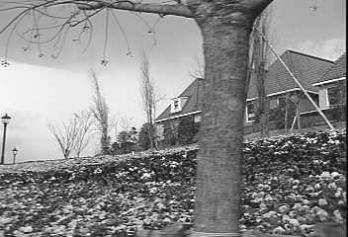
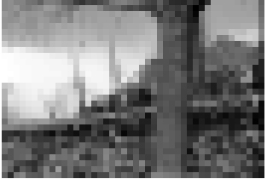
Fig 2. Original Image at 352 X 240 and the DC image at 44 X 30

DC Image Extraction for I frame
For I frames in MPEG the original image is grouped into 8 X 8 blocks. The DC image pixel c (0, 0) of each block (i.e. the 0th DCT coefficient of the DCT block) is related to the pixel value by
$c(0,0) = \frac{1}{8}\sum_{x=0}^{7}{\sum_{y=0}^{7}{f(x,y)}}$ (2)
this is 8 times the average intensity of the block. Therefore for I frame the (i, j) pixel of the DC image is 1/8 times the 0th DCT coefficient of the (i, j) block.

DC Image Extraction for P frame
We follow the approach given in [2]. To obtain the dc coefficients of P frames using the DCT coefficients from the previous I frame consider Fig. 3. Let P_{ref} be the current block of interest, P1, P2, P₃, and P4 the four original neighboring blocks from which P_{ref} is derived. Let P_{residue} be the residue frame.
It can be shown that [2]
$\begin{aligned}\text{DC}[P_{\text{cur}}] = \text{DC}[P_{\text{ref}}]+\text{DC}[P_{\text{residue}}] \\ \text{DC}[P_{\text{ref}}] = \sum_{i=1}^{4}{\frac{h_{i}w_{i}}{\text{64}}\text{DC}[P_{i}]}\end{aligned}$
(3)

(4)

where DC (P_{residue}), DC (P_{ref}) and DC (P_{cur}) are the 0th DCT coefficients of the residue block, reference block and current block respectively.
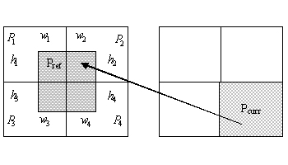 Fig. 3 Reference block and the Current block

C.DC images
Fig 4 shows the DC images extracted. The first frame is the I frame and the remaining frames are P frames.
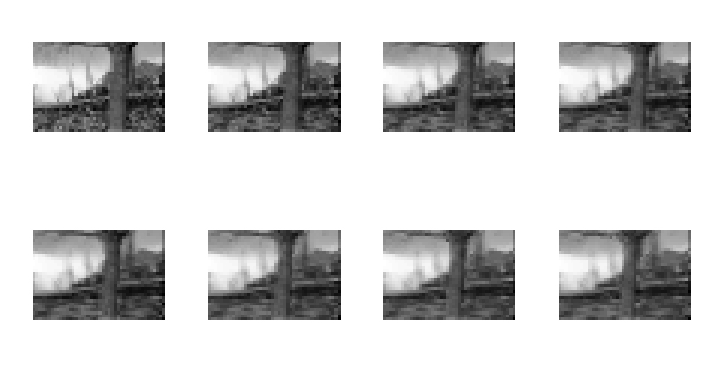Fig. 4 DC image sequence for first 8 frames

Transition Detection
In this section we make use of the DC sequences extracted from the compressed videos to perform temporal video segmentation of the video sequences. We implemented cut and wipe transition detection.

Cut Transition Detection
Here we rely on the measurement of successive pixel-level differences. Note that the DC images retain global image feature and this makes them ideal for scene change detection purposes. Let X= {x_{i, j}} and Y= {y_{i, j}} be two frames and their difference be denoted by d(X, Y) defined as

$d(X,Y)=\sum_{\text{ij}}{(x_{\text{ij}}−y_{\text{ij}})^{α}}$ (5)

Typically α = 1 or 2. In our implementation we have used α = 1. A plot of the frame differences shows a peak where the cut occurs. The threshold for detecting the cut transition is heuristically set or can be fine tuned.

Wipe Transition Detection-Variance method [4]
A wipe is a transition from one scene to another wherein the new scene is revealed by a moving boundary. A wipe can be either horizontal, vertical or diagonal. Apart from these there are a lot of other fancy types of wipes. A collection of different wipe patterns can be seen in [5]. Fig 5 shows a simplest form of wipe called the horizontal wipe, in which an old shot is gradually replaced by a new shot. Each frame during the transition is composed of two parts, one taken from the old shot and the other taken from the new shot. The boundary dividing the two parts is a vertical line that moves in such a way that at the end of the transition the entire frame is from the new shot Fig 6 is an example of a fancy diagonal wipe. We have implemented the wipe detection algorithm as proposed in [4]. The algorithm will be discussed with respect to horizontal wipes.



Fig. 5 Example of an Horizontal wipe


Fig. 6 Example of an fancy Diagonal wipe

The pixel wise difference method does not work well for wipe transitions. It can be seen from Fig 7. that the difference between two consecutive frames is mainly along a strip. Such strip is moving linearly from one side to the other during a wipe. A wipe typically lasts for 15 to 20 frames. Project the difference onto the vertical direction i.e. we sum up the differences along each column. The result is a plateau like shaped pattern shown in Fig 7. We can use the sample standard deviation to detect the occurrence of a 1-D plateau. Let S be the projected pixel wise difference deviation where S is defined as
$s=\sqrt{\frac{1}{n−1}\sum_{i=1}^{n}{(X_{i}−X_{\text{mean}})^{2}}}$
(6)

where n is the number of columns X_{i} is the projected pixel wise difference of the i^{th} column and X_{mean} is the mean.

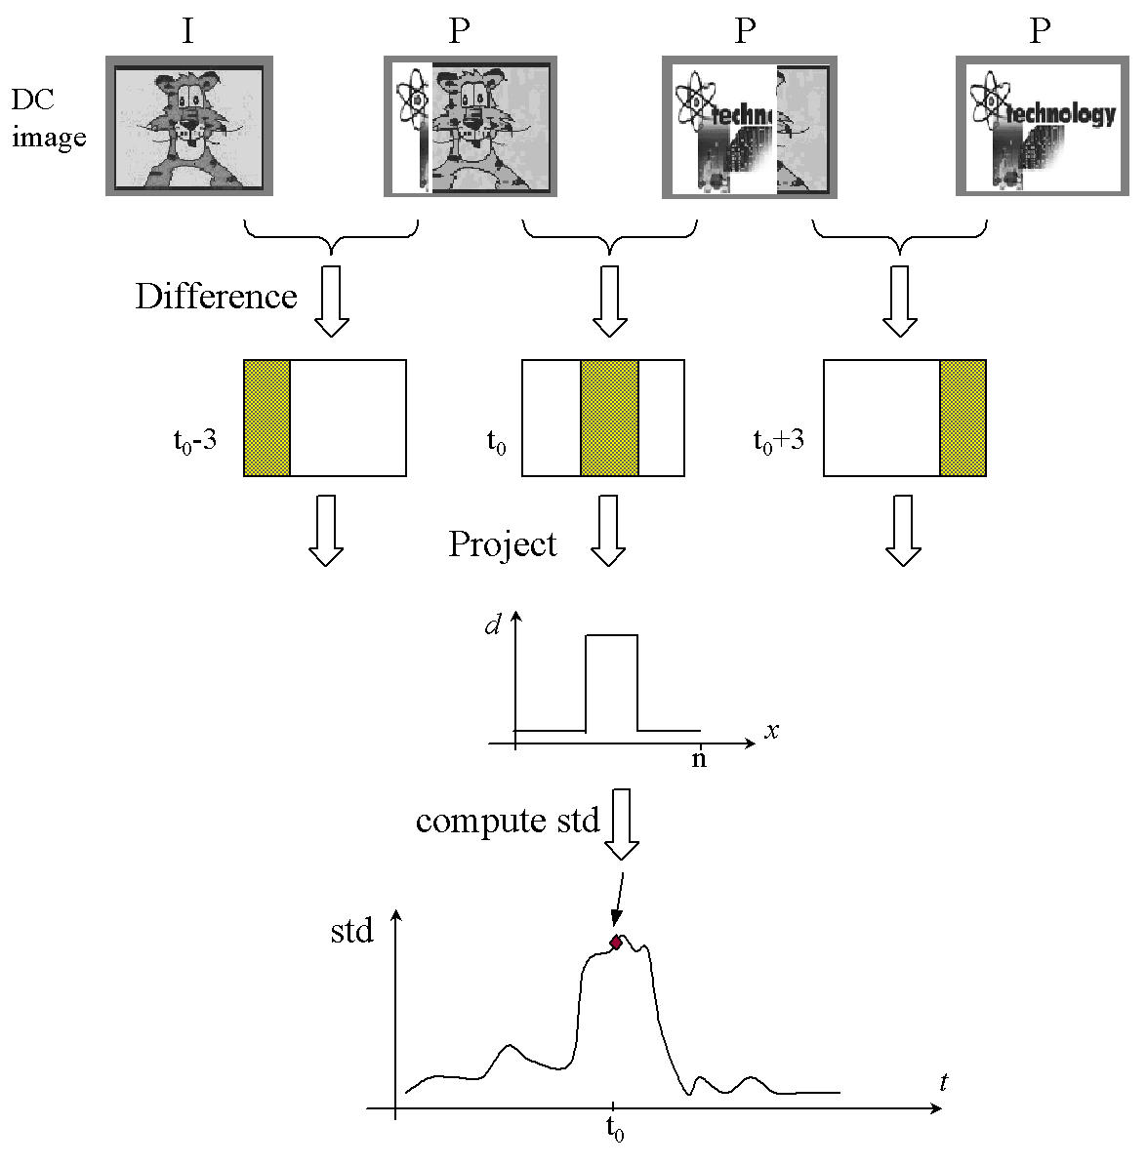 Fig. 7 Horizontal Wipe detection example

Wipe Detection – A new Algorithm
Let us consider a still video sequence being replaced by a different video sequence using the wipe technique. The frame difference is taken and a pixel is given a value of 0, 1 or 2 depending on the magnitude of the frame difference. Then if the frame differences are added together they should add upto a frame where all pixels have value 2, because each pixel of the old image is replaced by a pixel of the new image only once. In the practical case there is always some movement due to object motion and the frame sum is unlikely to add up to 2. The following steps can be taken to help computation and to make the algorithm more robust.
1. Compute the pixel wise difference F (i, j) between two consecutive frames.
2. Compute the mean of the difference frame as
$\text{mean}=\frac{\sum_{i,j}{F(i,j)}}{\sum_{i,j}{1}}$
(7)

3. Then the threshold frame is calculated using

$\begin{aligned}F_{\text{threshold}}(i,j)=u(F(i,j)−2\text{.}5 \text{mean})+ \\ u(F(i,j)−1\text{.}5 \text{mean})\end{aligned}$ (8)

where u( ) is the step function. This operation basically thresholds the difference frame. If the pixel value of the difference frame is greater then the threshold then it is set to 1 otherwise it is set to 0. The threshold value is chosen heuristically.
4. The frame sum is calculated by summing the thresholded frame differences over a window of length N. N is chosen based on the expected length of transition Generally a wipe sequence lasts for 15 to 20 frames
$F_{\text{sum}}(i,j)=\sum_{N \text{frames}}{F_{\text{threshold}}(i,j)}$
(9)

5. The variance of F_{sum} from the ideal frame (the ideal frame is the frame which consists of all 1’s) is calculated as
$\text{Deviation}=\sum_{\text{ij}}{(F_{\text{sum}}(i,j)−2)^{2}}$
(10)

$f=10\text{.}1+\text{deviation}$6. f gives a peak at the frame where a wipe transition begins where

(11)
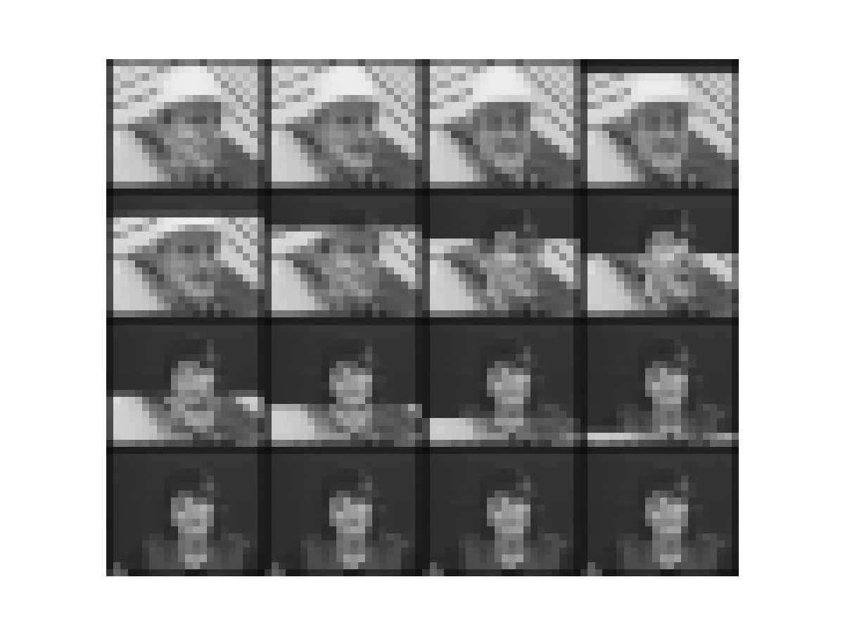
Fig. 8 Vertical Wipe Sequence

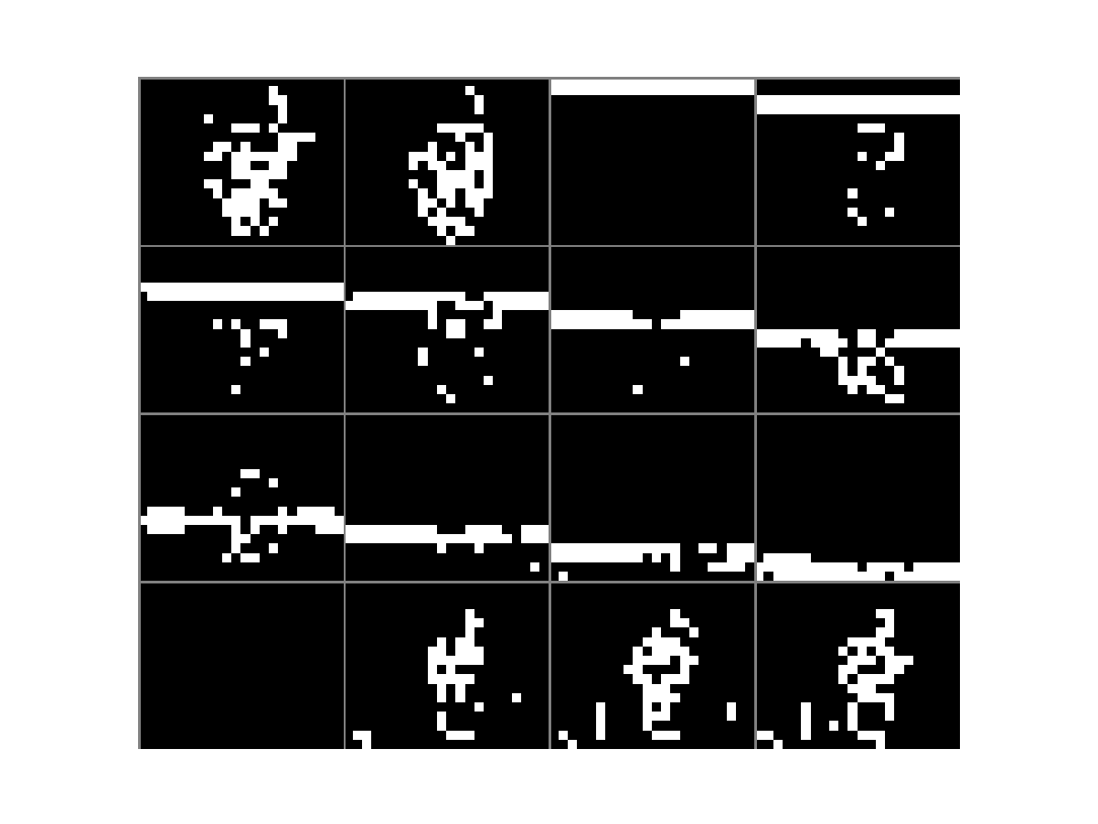
Fig. 8 Thresholded frame differences

Fig.8 shows a vertical wipe transition and Fig. 9 shows the corresponding thresholded frame differences. The horizontal band can be seen moving from the top to the bottom during the wipe. The noisy pixels are due to the object motion.

Experimental Results

Video Codec

Coding strategies for better compression

The INTRA/INTER decision for the macro block helps us obtain a better trade off between quality and compression. The graph indicating the percentage pf macro blocks that were coded INTRA is provided in the Fig. 9. In the football sequence, around 20% of the macro blocks have some severe motion component and have therefore been coded as INTRA macro blocks. In the tennis sequence motion is limited for the first part of the sequence and therefore a high proportion of the macro blocks have been coded as INTRA. The frame where the scene change occurs has a very high number of macro blocks being coded as INTRA and therefore the frame has been coded as an INTRA frame.
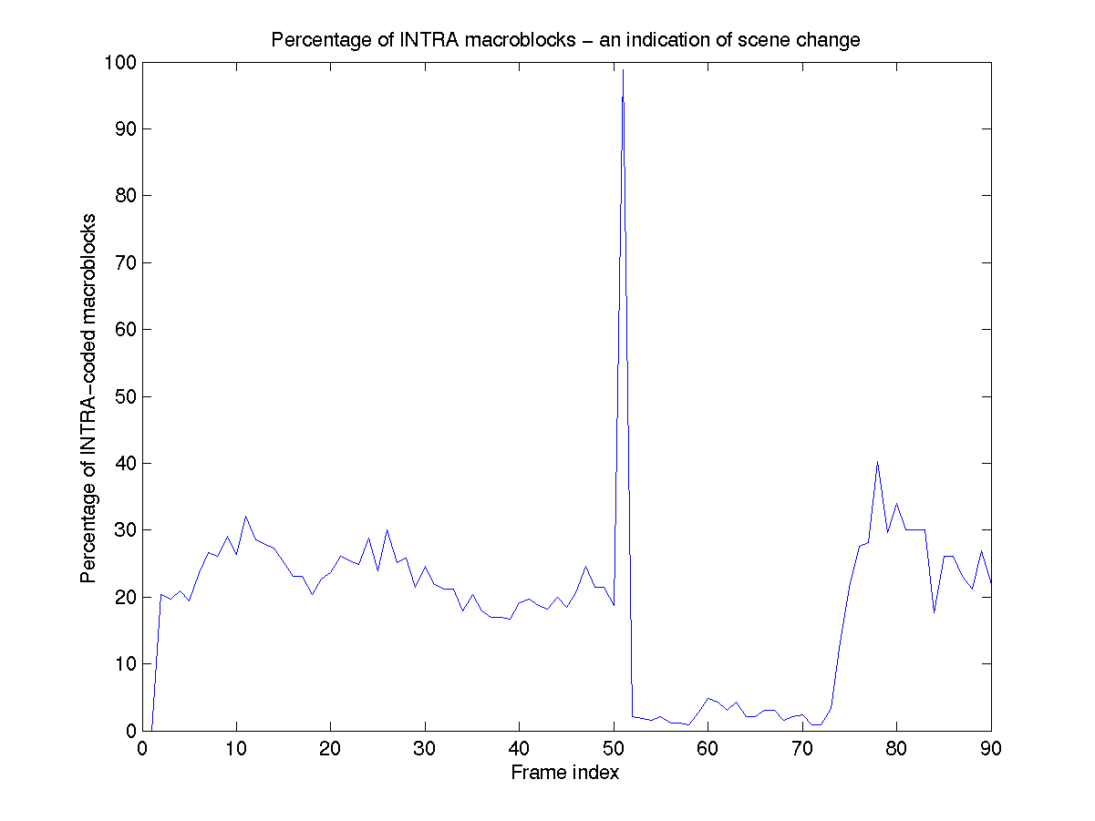
Fig 9. This figure indicates the number of Intra coded macro blocks in the sequence. The peak at 51 indicates the scene change.

TABLE I
Psnr Values for various Qfactors
Qfactor | PSNR (dB) | Compression Ratio
1.0 | 29.8 | 6
1.5 | 28.5 | 10
2.0 | 26.7 | 16
2.5 | 26.3 | 20
3.0 | 25.8 | 25
3.5 | 25.2 | 31

PSNR values
The Average PSNR value for the football+tennis sequence versus the compression has been plotted in Fig 10.
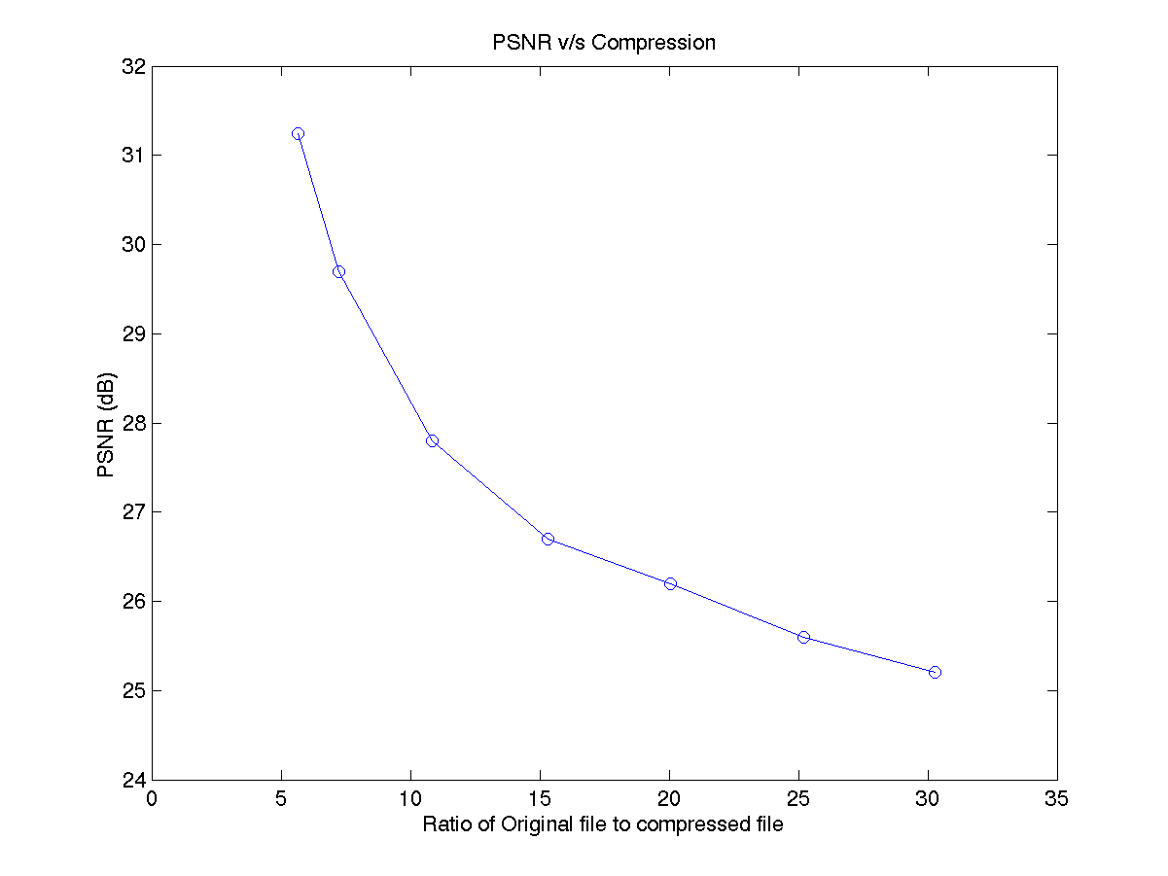

Fig. 10. This figure indicates the PSNR v/s compression for the football – tennis sequence. A acceptable picture quality is obtained for a compression ratio of 25:1.

Transition detection
We used a Sequence containing a vertical wipe and Cut transition. The total length of the test frames was 90. The vertical wipe transition occurs at 30th frame and ended at the 40th frame. The cut occurred at the 70th frame. The algorithm described in the previous sections is applied to the above test stream to detect horizontal wipe, vertical wipe and cut transitions.
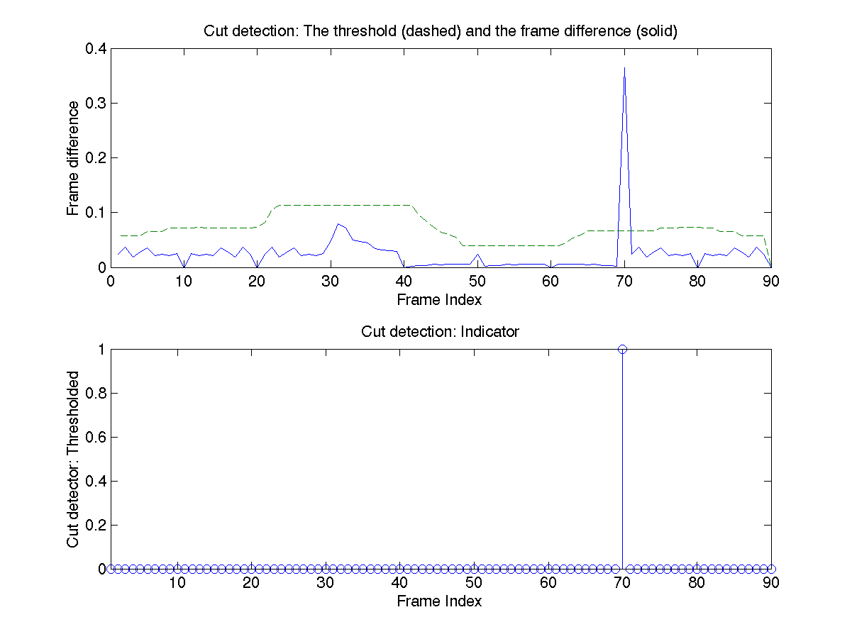
Fig 11. This figure indicates the successive frame differences. The peak at the 70th frame is the cut transition.

Fig 11 shows the results for the cut transition detection. The frame wise difference shows a peak at the 70th frame. Fig 12 shows the results using the variance method for wipe detection. The vertical wipe is correctly detected as between 30th and the 40th frame. Since there are no horizontal wipes in the test video stream the plot of the variance of the projected frame difference for the horizontal wipe does not show any peak. The plots also show a peak at the 70th frame which corresponds to the cut transition. Fig 13 shows the frame difference projected on the Y and X axis for vertical and horizontal wipe transitions respectively. For vertical transition we can see the band moving from the 30th to the 40th frame.
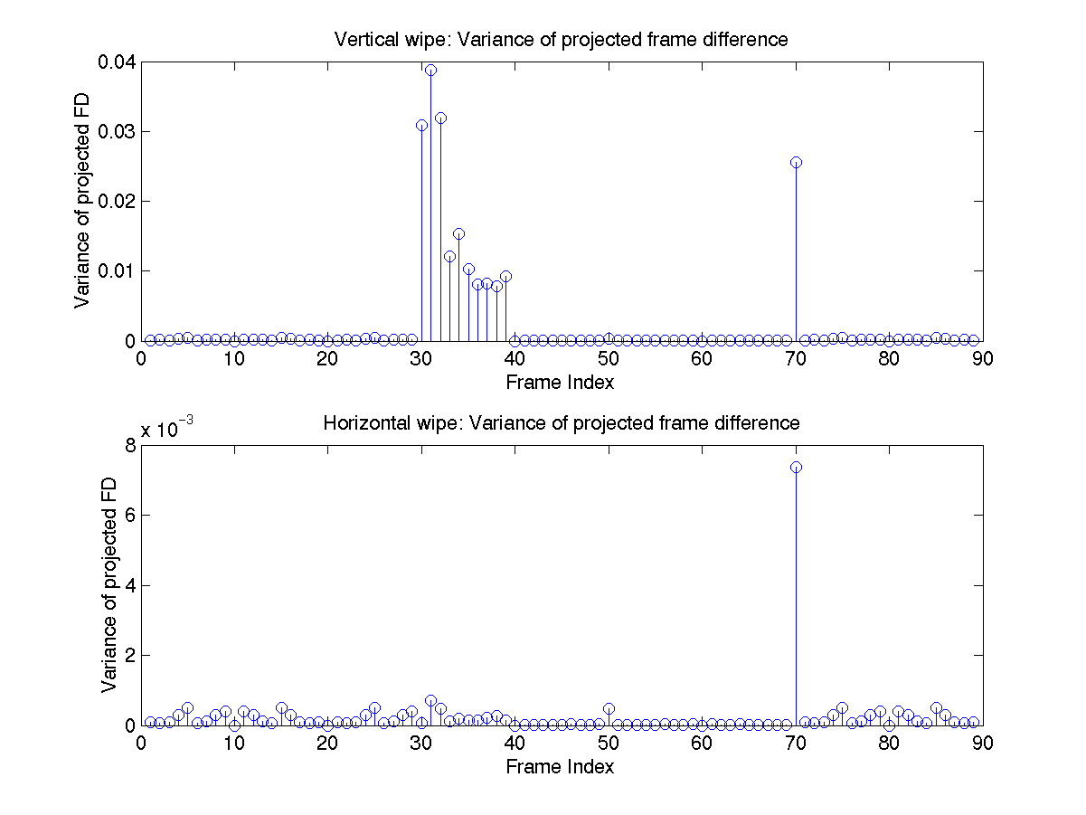

Fig. 12. This figure indicates the variance of the projected frame difference for both vertical and horizontal wipes.

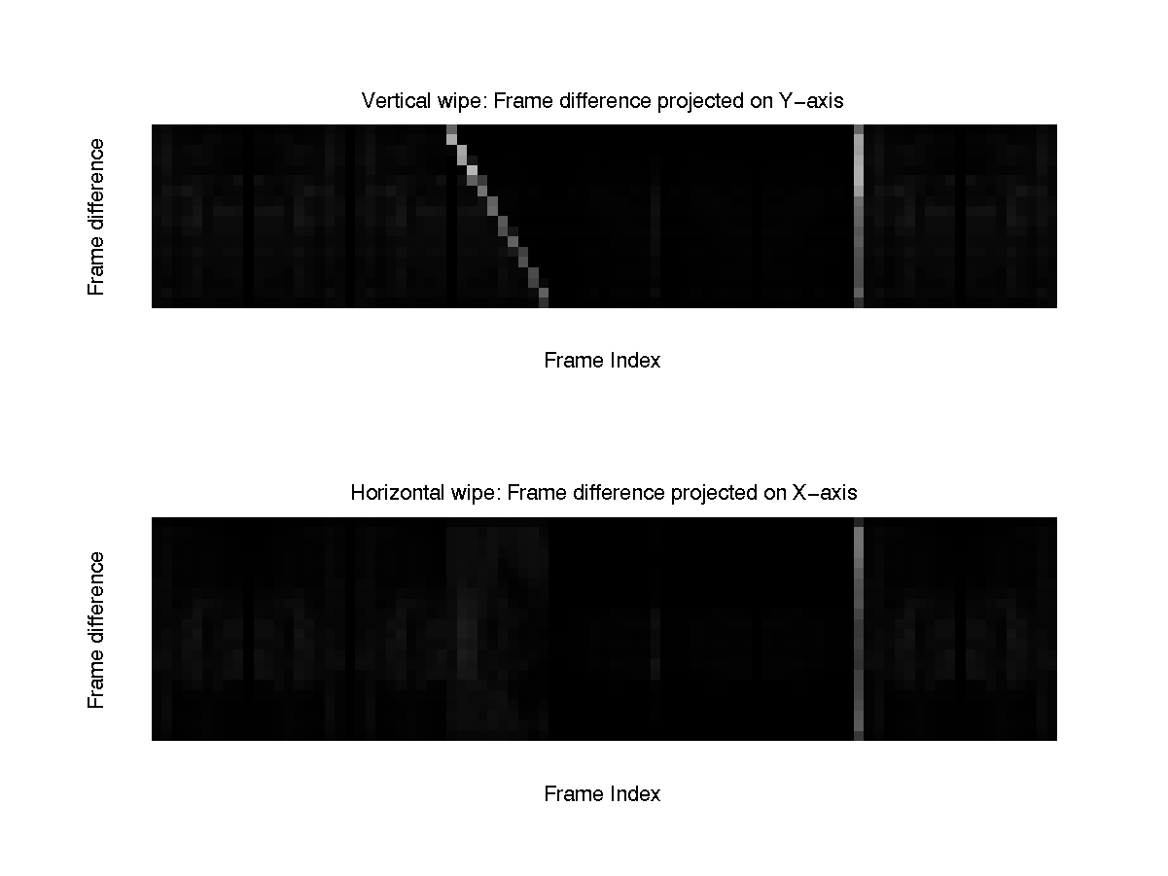
Fig. 13. This figure indicates the frame difference projected on the respective axes(Y for horizontal and X for vertical)

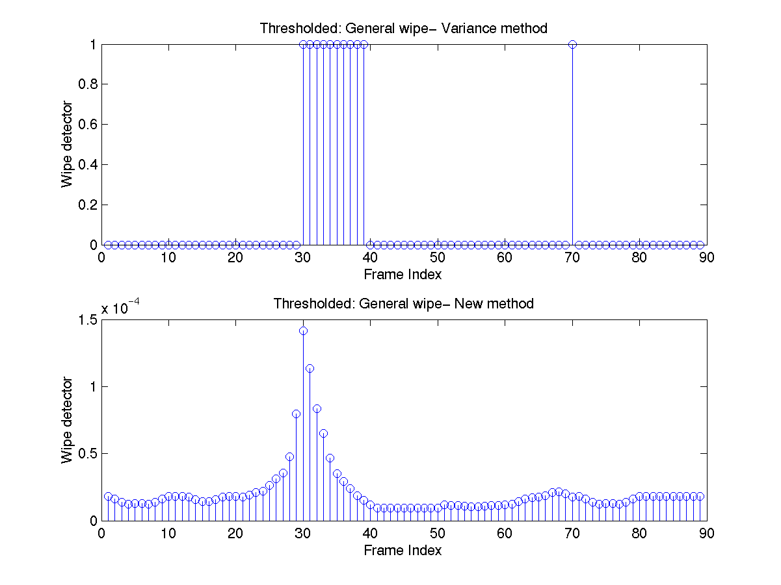
Fig. 14. Comparison of the variance and the new method
Fig 14 shows the results using the new algorithm proposed for wipe detection variance method for wipe detection. The beginning of the wipe is correctly detected by the new method.

Conclusion
We have implemented the video codec and also a program for DC image extraction and cut and wipe transition detection. The video codec provides good compression for normal sequences with moderate motion (such as the football+tennis sequence). However for high complexity sequences which also have global motion (such as the garden sequence), the compression is not very high. Future work can focus on means to obtain better compression using better temporal prediction techniques such as global motion detection, bidirectional prediction and also half pel precision motion estimation. DC images are extracted from the compressed domain MPEG stream. Cut transition was detected using the pixel wise difference method. Wipe transition was detected using the variance method. A new method for detecting wipe transitions was proposed. The new method was found to give satisfactory results for horizontal and vertical wipes.
Acknowledgment
We are grateful to Prof. Wu and Mr. Su for their help and advice at the various stages of the project. We are also thankful to other students in the course who provided comments and help.
References
- J Boreczky and L Rowe. Comparison of video shot boundary detection techniques. In SPIE Conf. Storage & Retrieval for Image & Video Databases, volume 2670, pages 170--179, 1996.
- B. L. Yeo and B. Liu, "On the extraction of dc sequence from mpeg compressed video," in Proceedings of the IEEE ICIP, 1995.
- B. Yeo, and B. Liu, "Rapid scene analysis on compressed videos", IEEE Trans. Circuits Sys. Video Tech., Vol. 5, No. 6, pp. 533-544, December 1995.
- Wu, M., W. Wolf, and B. Liu, "An Algorithm for Wipe Detection," ICIP '98, Chicago (1998)
- http://www.ee.princeton.edu/~robjoyce/research/transitions/
- H. S. Hou. A fast recursive algorithm for computing the discrete cosine transform. IEEE Transactions on Acoustics, Speech, and Signal Processing, ASSP-35(10):1455-1461, October 1987.
- W.H. Chen, C.H. Smith, and S.C. Fralick, ``A Fast Computational Algorithm for the Discrete Cosine Transform,'' IEEE Trans. on Communications, Vol. COM-25, pp. 1004--1009, 1977.

Aravind Sundaresan is a graduate student at the University of Maryland College Park, MD 40742 USA (telephone: 301-405-3935, e-mail: aravinds@glue.umd.edu).
Vikas Chandrakant Raykar is a graduate student at the University of Maryland College Park, MD 40742 USA (telephone: 301-405-1208, e-mail: vikas@glue.umd.edu ).

 This report was written for ENEE 631 FALL 2001 as a part of the course project. The authors are graduate students at Department of Electrical Engineering, University of Maryland, and College Park MD 40742 USA.

